Patent the greatest invention of all time!

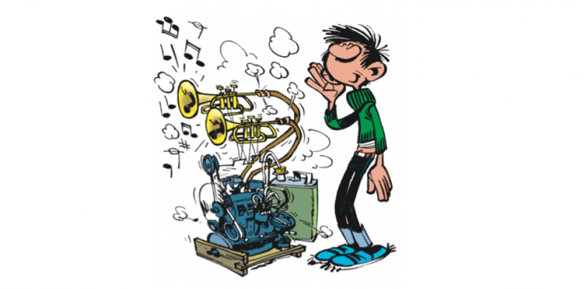

In a world where climate is changing, mankind will have to adapt. Thus, you will have to create a revolutionary invention that will help humanity living on a more hostile Earth.

In pairs, write the patent1 of this invention. It must include the following items: a title, the background of the invention, drawings to help others understand and picture it, and a thorough2 description (what it is for, how to use it, what in looks like, why is it revolutionary…).

You will have to hand in your work on ……………………………… .

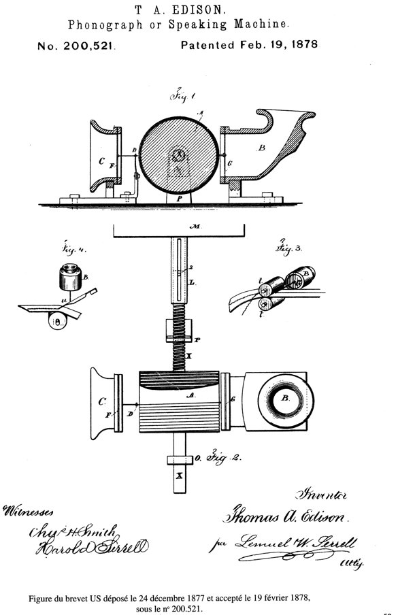

Schedule:

* First session (………………………): instructions, teams, brainstorming
* Second session (………………………): gather ideas found at home and start writing the patent
* Third session (………………………): finish the patent
* Fourth session (………………………): last details/hand in your work

You will be assessed3 on the following criteria:

* Quality of your English (grammar, spelling, vocabulary…) 4 points
* Instructions followed (way to hand in your work, due date respected…) 2 points
* Thoroughness of your work
  + Title 2 points
  + Une image contenant texte, graphiques vectoriels, lumière

    Description générée automatiquementBackground 2 points
  + Description 4 points
  + Drawings 3 points
  + Creativity 3 points

1 patent: *breveter/brevet*

2 thorough: *minutieux*

3 assess: *évaluer*