Corrélation et causalité | Chap 0
Nom Prénom : | 1ère ES

Le 10 octobre 2012, Franz H Messerli publie un article scientifique attestant qu’un pays peut augmenter son nombre de prix Nobel en mangeant du chocolat.
“Results:
There was a close, significant linear correlation (r=0.791, P<0,0001) between chocolate consumption per capita and the number of Nobel laureates per 10 million persons in a total of 23 countries (Fig. 1). When recalculated with the exclusion of Sweden, the correlation coefficient increased to 0.862. Switzerland was the top performer in terms of both the number of Nobel laureates and chocolate consumption. The slope of the regression line allows us to estimate that it would take about 0.4 kg of chocolate per capita per year to increase the number of Nobel laureates in a given country by 1. For the United States, that would amount to 125 million kg per year.”
Ci-dessous, le graphique présenté dans l’article.
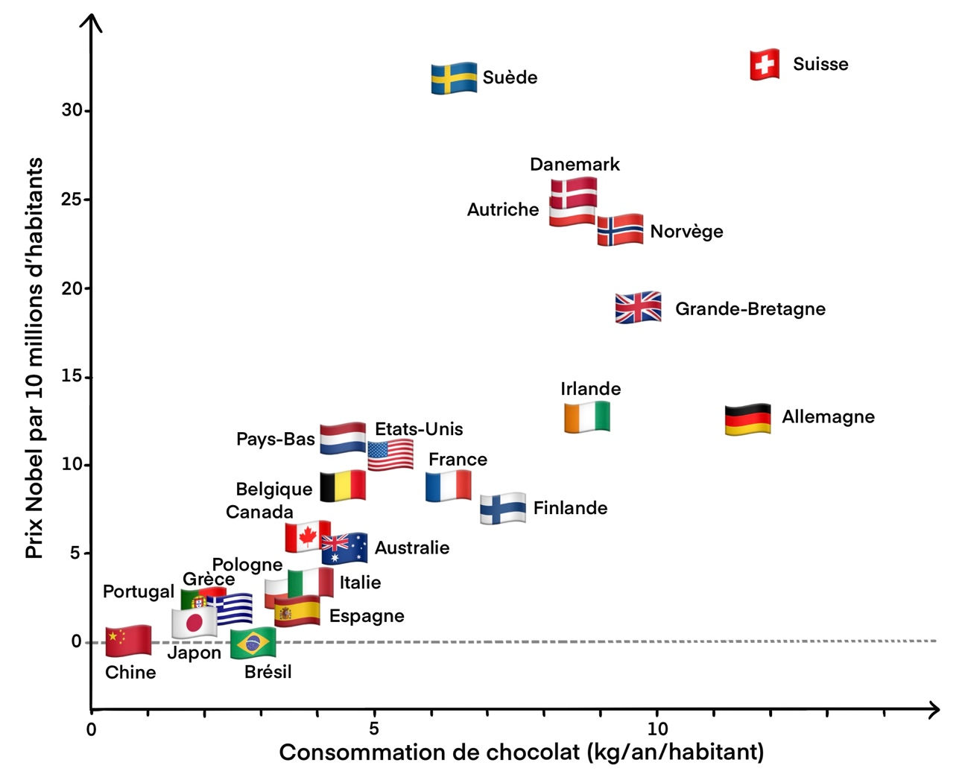
On peut remarquer que ces deux variables sont corrélées mais existe-il pour autant un lien de causalité ?

- Dans quel cas dit-on que deux variables sont corrélées ? Donner un exemple (autre que chocolat et prix Nobel).
…………………………………………………………………………………………………………………………………………………………………
…………………………………………………………………………………………………………………………………………………………………
…………………………………………………………………………………………………………………………………………………………………
- Quels sont les deux types de corrélations qui existent ? Les définir.
…………………………………………………………………………………………………………………………………………………………………
…………………………………………………………………………………………………………………………………………………………………
- Dans quel cas deux variables ont-elles un lien de causalité ? Donner un exemple.
……………………………………………………………………………………………………………………………………………………………………………………………………………………………………………………………………………………………………………………………………
…………………………………………………………………………………………………………………………………………………………………
- Qu’est-ce qu’une variable de confusion ?
…………………………………………………………………………………………………………………………………………………………………
…………………………………………………………………………………………………………………………………………………………………
- Dans l’exemple donné p. 17 de votre manuel scolaire (nombre de cigognes et de bébés), quelle est la variable de confusion ?
…………………………………………………………………………………………………………………………………………………………………
…………………………………………………………………………………………………………………………………………………………………
…………………………………………………………………………………………………………………………………………………………………
- Aller chercher sur le bureau du professeur un couple de courbes ou de cartes corrélées et imaginer une interprétation de votre choix, prenant la forme d’un paragraphe argumentatif sur le modèle de celui p. 17 avec la vente de disque vinyles.
Scanne-moi pour retrouver tous les liens utiles !
…………………………………………………………………………………………………………………………………………………………………
…………………………………………………………………………………………………………………………………………………………………
…………………………………………………………………………………………………………………………………………………………………
…………………………………………………………………………………………………………………………………………………………………
…………………………………………………………………………………………………………………………………………………………………
…………………………………………………………………………………………………………………………………………………………………
…………………………………………………………………………………………………………………………………………………………………
…………………………………………………………………………………………………………………………………………………………………
…………………………………………………………………………………………………………………………………………………………………
…………………………………………………………………………………………………………………………………………………………………
…………………………………………………………………………………………………………………………………………………………………
…………………………………………………………………………………………………………………………………………………………………
Scanne-moi pour retrouver tous les liens utiles !
…………………………………………………………………………………………………………………………………………………………………
…………………………………………………………………………………………………………………………………………………………………
…………………………………………………………………………………………………………………………………………………………………
…………………………………………………………………………………………………………………………………………………………………
…………………………………………………………………………………………………………………………………………………………………
…………………………………………………………………………………………………………………………………………………………………
…………………………………………………………………………………………………………………………………………………………………

