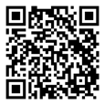
Patent the greatest invention of all time!

In pairs, you will have to create and write the patent¹ of a revolutionary invention (useful or not). Your invention will have to be somehow related to science.
You will have to hand in your work on ……………………………… .

Your patent must include the following items: a title, the background of the invention, a summary of the invention, drawings to help others understand and picture it, and a thorough² description (what it is for, how to use it, what in looks like, why is it revolutionary…).
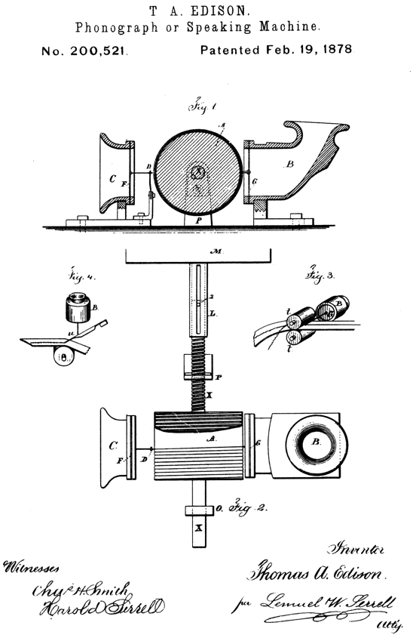
At the end of the month, you will have to present your invention to the rest of the students. The presentation must last between 2 and 3 minutes. On the last day of the presentations, you will vote for the 3 greatest invention, and the happy creators will win 3, 2 or 1 bonus points!

Schedule:
- First session (………………………): instructions, teams, brainstorming
- Second session (………………………): gathering ideas found at home
- Third session (………………………): write the patent
- Fourth session (………………………): hand in your work, presentations
- Fifth session (………………………): presentations
- Sixth session (………………………): presentations

You will be assessed³ on the following criteria:
- Quality of your English (grammar, spelling, vocabulary…) 4 points
- Instructions followed (way to hand in your work, due date respected…) 2 points
- Thoroughness of your work
  - Title 1 point
  - Background 2 points
  - Summary & description 4 points
  - Drawings 2 points
  - Creativity 2 points
- Presentation
  - Communication skills (voice modulation, intonation, rhythm, fluency…) 3 points
  - Language skills (pronunciation, vocabulary, grammar…) 3 points
  - Duration 2 points

¹ patent: breveter/brevet
² thorough: minutieux
³ assess: évaluer

